**TASK 1**

select customer.customer_name, loan.loan_number from ((customer inner join borrower on customer.customer_id = borrower.customer_id) inner join loan on loan.loan_number = borrower.loan_number) where loan.branch_name = 'Downtown';

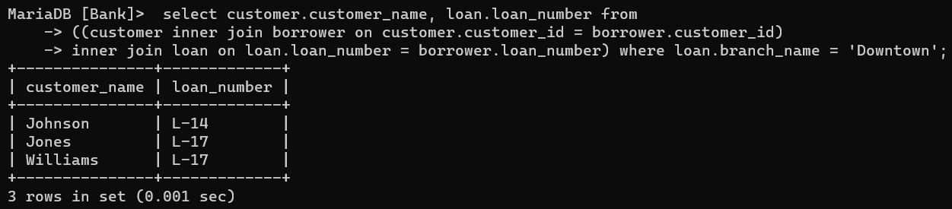

**TASK 2**

select b1.customer_name, b2.customer_name, b2.customer_city from customer as b2, customer as b1 where b2.customer_city =b1.customer_city and b1.customer_id < b2.customer_id;

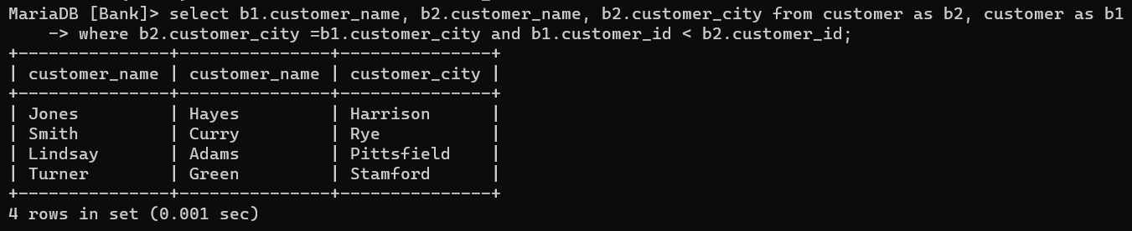

**TASK 3**

select branch_name as Branch_name, sum((4 / 100) * balance) as Total_interest from account group by branch_name;

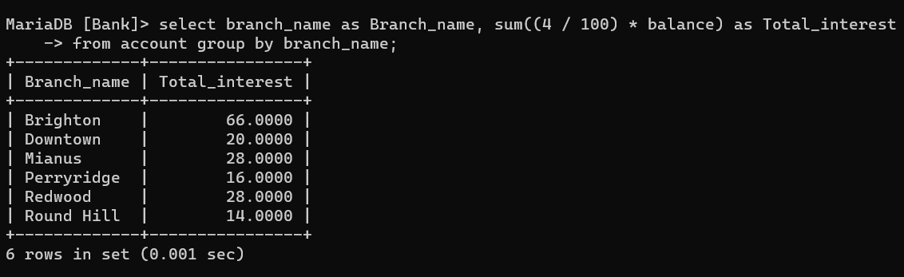

**TASK 4**

select b1.account_number from account b1 inner join branch b2 on b2.branch_name = b1.branch_name where (branch_city, balance) in (select branch_city, max(balance) from account b1 inner join branch b2 on b2.branch_name = b1.branch_name group by branch_city);

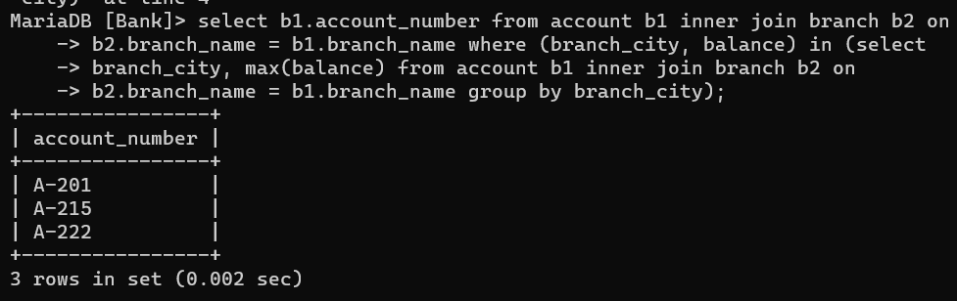

**TASK 5**

select * from (select l1.loan_number, l2.amount, l3.customer_name from borrower l1 inner join customer l3 on l1.customer_id = l3.customer_id inner join loan l2 on l1.loan_number = l2.loan_number order by amount desc limit 5) as table1 order by amount, loan_number desc;

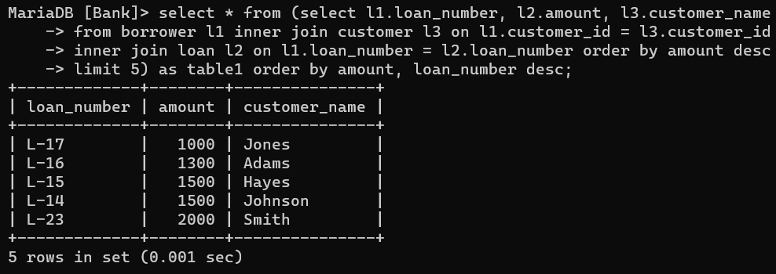

**TASK 6**

select c.customer_id, c.customer_name, l.amount from customer c inner join depositor d ON c.customer_id = d.customer_id inner join borrower b ON b.customer_id = d.customer_id inner join loan l ON b.loan_number = l.loan_number and l.branch_name = "Perryridge";

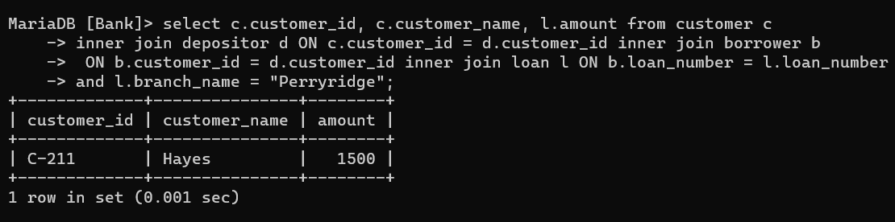

**TASK 7**

select b1.customer_name, sum(b2.amount) as total_loan from customer b1 inner join borrower b3 on b1.customer_id = b3.customer_id inner join loan b2 on b3.loan_number = b2.loan_number group by b1.customer_id having (count(*) >= 2);

